ELECTRONIC VOTING PLATFORM
ASSIGNMENT 3 | GROUP SUBMISSION REPORT
Secure Software Systems
Group Members
Name | Student ID
Ankitha Devlokam | S4200610
Sania Muskan Shaik | S4198142
Gunjan Trapasiya | S4187960
Gayathri Devi Peketi | S4182247
Source repository: https://github.com/ankithadevlokam/ELECTRONIC-VOTING-PLATFORM
Project overview
We developed an Electronic Voting Platform prototype centred on ballot secrecy, prevention of duplicate voting and secure management of voting credentials. Our work began by identifying and evaluating 20 security requirements. We then implemented and tested the supporting backend services and developed a three-stage browser interface for obtaining a credential, choosing a candidate and submitting a ballot.
The prototype uses demonstration voter and candidate records. The documented backend employs Python 3.11, Flask, Flask-SQLAlchemy, SQLite, Argon2 and pytest. The interface uses HTML, CSS and JavaScript. We present the implementation progressively, from requirements and solution decisions to the data model, services, tests and observed application behaviour.
Contents
Part 1. Security requirements identification and prioritisation
Part 2. Security solution selection and cost-benefit analysis
Part 3. Prototype implementation, security testing and demonstration
Conclusion and implementation scope

Part 1 — Security Requirements Identification and Prioritisation
1.1 Requirements identification
We analysed the voting process from voter registration and eligibility checks through ballot submission, storage and election administration. The principal threats considered were identity theft, unauthorised or repeated voting, disclosure of ballot choices, manipulation of election records and disruption of voting services. We consolidated these concerns into 20 distinct security requirements and assigned each a priority and implementation-complexity rating.
The requirements cover confidentiality, integrity, availability and accountability. Our complexity ratings reflect the effort involved in implementing and testing the control in a voting context, not only the availability of a library or standard implementation.
1.2 Security requirements
ID | Security requirement | Priority | Complexity
SR01 | Secure voter authentication | High | High
SR02 | Multi-factor authentication for privileged accounts | High | Medium
SR03 | Prevention of duplicate voting | High | High
SR04 | Encryption of voting data | High | High
SR05 | Role-based access control | High | Medium
SR06 | Secure voter registration | High | Medium
SR07 | Ballot secrecy and voter anonymity | High | High
SR08 | Intrusion detection and monitoring | High | Medium
SR09 | Secure communication using HTTPS/TLS | High | Medium
SR10 | Protection against SQL injection | High | Medium
SR11 | Protection against cross-site scripting | Medium | Medium
SR12 | Secure password storage | High | Low
SR13 | Session management and timeout | Medium | Low
SR14 | Tamper-evident voting records | High | High
SR15 | Secure backup and recovery | High | High
SR16 | Distributed denial-of-service protection | High | High
SR17 | Election audit logging | High | Medium
SR18 | Secure election result calculation | High | High
SR19 | Secure software configuration | Medium | Low
SR20 | Error handling and information disclosure prevention | Medium | Low
1.3 Prioritisation and scope
We classified requirements that directly affect voter legitimacy, ballot confidentiality, election integrity and critical service availability as high priority. SR03, Prevention of Duplicate Voting, and SR07, Ballot Secrecy and Voter Anonymity, were particularly important because a successful attack against either could compromise the fairness or secrecy of an election.
Our classification contains eight high-complexity requirements, eight medium-complexity requirements and four low-complexity requirements. We treated atomic voting transactions, anonymity, encrypted ballot handling and reliable election-result calculation as more complex than controls supported by mature standard libraries. These priorities guided our choice of implementation scope.

Part 2 — Security Solutions and Cost-Benefit Analysis
2.1 Evaluation approach
For each security requirement, we compared practical alternatives and selected the approach offering the strongest reasonable security benefit for the expected implementation and maintenance effort. We used qualitative Low, Medium, High and Very High ratings. These ratings express relative trade-offs rather than verified monetary costs.
2.2 Comparison of solutions
ID | Potential solutions | Cost / benefit | Preferred solution and justification
SR01 | Password-only authentication versus identity verification with additional authentication controls | Medium / High | Strong identity verification with authentication controls reduces impersonation risks.
SR02 | SMS OTP versus authenticator application or hardware security key | Medium / High | Phishing-resistant hardware security keys are preferred for privileged administrator accounts.
SR03 | Application-level duplicate checks versus transactional database constraints | Medium / Very High | Database transactions and uniqueness constraints provide stronger protection against simultaneous duplicate submissions.
SR04 | Database encryption versus application-level encryption with managed keys | High / Very High | Application-level encryption and controlled key management offer stronger separation of sensitive ballot data.
SR05 | Individual permissions versus role-based access control | Low / High | RBAC simplifies administration and supports least-privilege access.
SR06 | Manual document checks versus digital enrolment verification | Medium / High | Authorised enrolment verification combined with validation controls reduces fraudulent registrations.
SR07 | Basic anonymisation versus cryptographic separation of identity and ballots | High / Very High | Cryptographic ballot separation better protects voter anonymity.
SR08 | Manual log reviews versus centralised monitoring and intrusion detection | Medium / High | Centralised monitoring supports earlier detection and investigation.
SR09 | HTTP versus HTTPS with modern TLS | Low / High | HTTPS protects information in transit against interception and modification.
SR10 | Manual input filtering versus parameterised queries | Low / High | Parameterised queries prevent user input from being interpreted as SQL commands.
SR11 | Input sanitisation versus contextual output encoding and CSP | Low / High | Contextual encoding with a Content Security Policy provides layered XSS protection.
SR12 | SHA-256 hashing versus Argon2id password hashing | Low / High | Argon2id is designed for password storage and resists password-guessing attacks better than fast general-purpose hashing.
SR13 | Persistent sessions versus expiring secure sessions | Low / Medium | Secure cookies, session rotation and inactivity timeouts reduce session misuse.
SR14 | Ordinary database records versus cryptographically signed audit records | High / Very High | Digital signatures and protected audit storage help reveal unauthorised modifications.
SR15 | Local backups versus encrypted off-site backups with recovery testing | Medium / High | Encrypted off-site backups improve recovery following system failure or ransomware.
SR16 | Basic firewall rules versus managed DDoS mitigation and rate limiting | High / High | Layered DDoS protection helps maintain platform availability during attacks.
SR17 | Local application logs versus centralised, access-controlled audit logs | Medium / High | Centralised records improve accountability and forensic investigation.
SR18 | Basic result counting versus independently tested deterministic tallying | High / Very High | Tested and independently verifiable tallying reduces calculation and manipulation risks.
SR19 | Manual configuration versus automated secure configuration baselines | Low / Medium | Standardised configurations reduce deployment mistakes.
SR20 | Detailed user-facing errors versus controlled error responses | Low / Medium | Generic user errors and protected internal logging reduce information leakage.
2.3 Security trade-offs
Established controls such as parameterised queries, Argon2 password verification and contextual output handling can be implemented using maintained frameworks and libraries. Their effectiveness still depends on correct integration and configuration. Role-based access control can simplify permission management, while authenticated encryption helps protect sensitive ballot contents when encryption keys are adequately secured.
Other controls require larger operational commitments. Hardware-backed administrator authentication adds device and recovery considerations; central monitoring and DDoS mitigation require infrastructure and response processes; backups require recovery validation. Cryptographic ballot secrecy is especially demanding because encrypting ballot content and omitting a voter ID do not, by themselves, eliminate all linkage through system metadata or credential handling.
2.4 Selected security design: SR07
We selected SR07, Ballot Secrecy and Voter Anonymity, as the primary implementation focus. Our chosen prototype design separates eligibility information from stored ballot content and authorises submission through high-entropy, one-use credentials. We also prioritised SR03 through issuance and consumption controls, and SR04 through ballot encryption handling. This combination reduces direct identity linkage and supports one ballot per credential, subject to the limitations described in our evaluation.
The implementation choices reflect the intended sequence: establish an eligible voter record, issue a random credential, validate the selected ballot, consume the credential once and store the ballot data without a direct voter foreign key.

Part 3 — Implementation of the Electronic Voting Platform
3.1 Technology stack and system flow
We organised the prototype around the browser interface, Flask REST API, security services and SQLite database. The frontend handles the voter-facing steps, while backend modules implement credential generation, eligibility checks, one-use consumption, election validation and transaction processing. SQLAlchemy maps the voter, credential and ballot records to separate database tables.
Layer | Technology / responsibility
User interface | HTML, CSS and JavaScript; credential request, candidate selection, review and submission
Application API | Flask routes for health, election information, credential issuance and ballot submission
Security services | Random credentials, SHA-256 credential hashes, one-use checks, Argon2 development login, session/CSRF controls
Persistence | SQLite database managed with Flask-SQLAlchemy
Verification | pytest unit and API tests; browser and PowerShell evidence
The implementation records a credential-issued flag against the voter and a used flag against the credential. Ballot records do not directly embed voter identity. The documented service-level ballot workflow processes encryption output and credential consumption in one transaction, allowing rollback if a step fails.
3.2 Database structure and identity separation
We created and inspected three tables: voters, voting_credentials and ballots. The voters table contains a voter reference, eligibility and issuance state. The credential table stores a SHA-256 digest and consumption state. The ballot table stores encrypted_vote bytes and a timestamp, without a direct voter ID or voter-reference column.
We checked the schema through the running Flask application and database tests. The absence of a direct voter field in the ballot table provides structural separation, rather than a mathematical proof of unlinkability across every possible metadata source.
Figure 1: SQLite tables verified in the Flask application
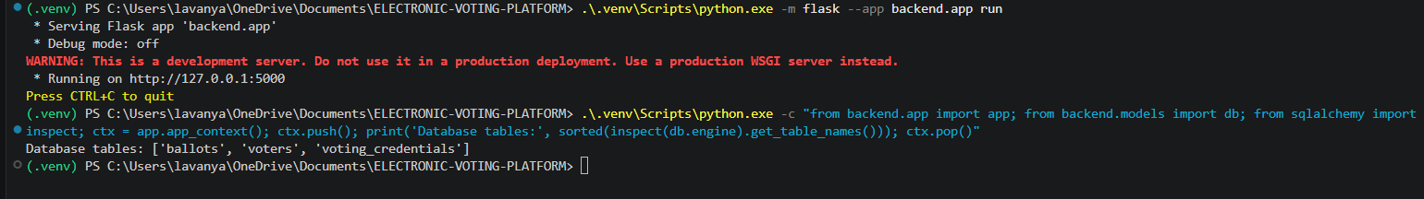
Figure 2: Database structure and voter/ballot separation tests passed
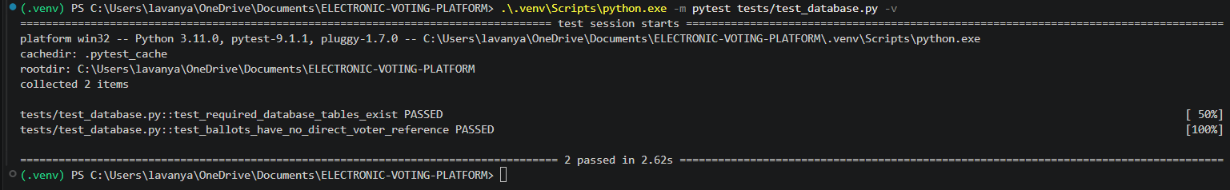
3.3 Credential generation and secure lookup
We generated voting credentials with secrets.token_urlsafe(32), using cryptographically secure randomness. The API stores a SHA-256 digest of the high-entropy token instead of the original token. This design supports credential lookup while avoiding plaintext storage of the bearer credential. Password verification is treated separately using Argon2, which is appropriate for human-chosen secrets.
Our credential tests checked type, input handling, repeatable hashing and the uniqueness of 1,000 generated tokens. The test outcomes supported the expected operation of these functions under the tested conditions.
Figure 3: Random credential generation and hashing tests passed
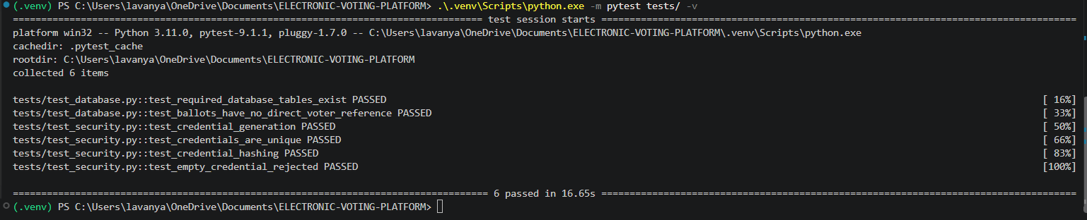
3.4 Eligibility and controlled credential issuance
The issuance service applies an eligibility check and a conditional database update requiring the voter to have no previously issued credential. After a successful update, the service creates and stores the credential digest. Both changes are committed together. On a failure, the operation rolls back to avoid leaving the database in a partially issued state.
We tested eligible issuance, rejection of ineligible voters, repeated issuance and rollback after a simulated failure. We also registered a demonstration voter for browser testing, confirming the reference voter-demo-001 through PowerShell.
Figure 4: Credential issuance and rollback tests passed
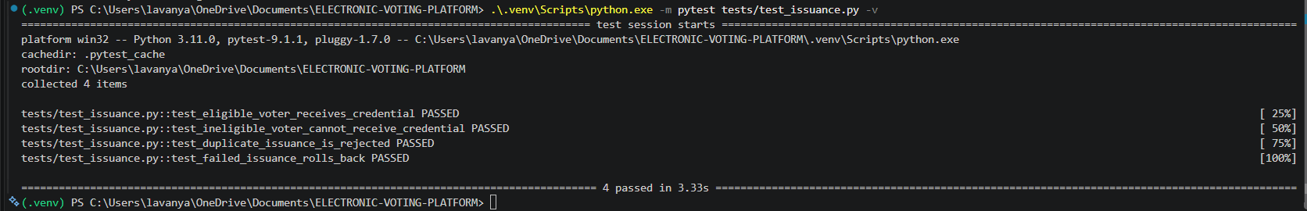
Figure 5: Registration of the demonstration voter in the application database
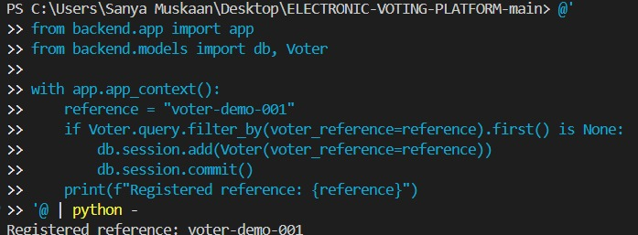
3.5 One-use credential consumption
When a credential is redeemed, the backend hashes the supplied token and performs a conditional update that succeeds only for an unused matching record. The function leaves the final transaction commit to the ballot service. This allows the application to roll back credential consumption if ballot storage does not succeed.
We tested accepted consumption, duplicate reuse rejection, invalid and empty credentials, and rollback behaviour. The results establish the expected sequential behaviour. They do not constitute a full stress test of simultaneous requests under production database concurrency.
Figure 6: One-use credential consumption and rollback tests passed
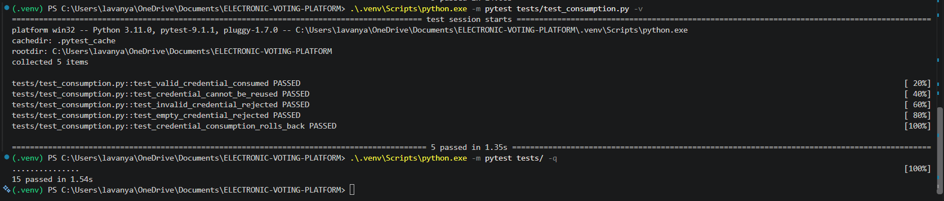
3.6 Ballot validation and transactional storage
The backend ballot service validates submitted candidate information, serialises the result, invokes an encryption interface and records the ballot while consuming the credential in the same database transaction. Any exception before commit triggers a rollback. For isolated service and API tests, we passed a test-only encryption function so that validation and transaction safety could be exercised independently.
The documented backend election validator also checked a three-candidate preference ranking. The final browser interface demonstrates a simpler single-candidate ballot, so the screenshots evidence that specific user-facing voting mode rather than a complete Australian preferential ballot.
Figure 7: Ballot submission and transaction-failure tests passed
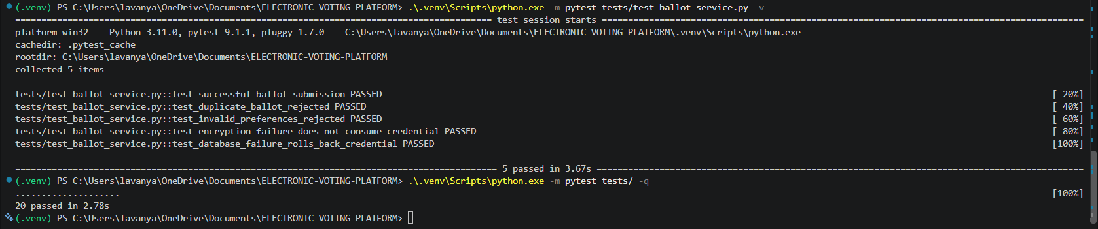
Figure 8: Manual election validation: accepted ranking and rejected unknown candidate
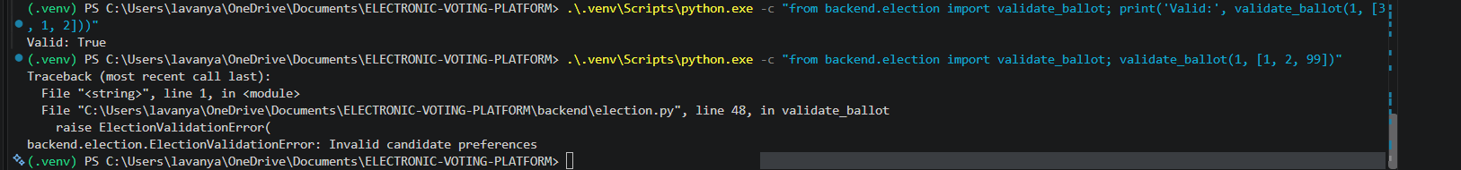
Figure 9: Automated election validation tests passed
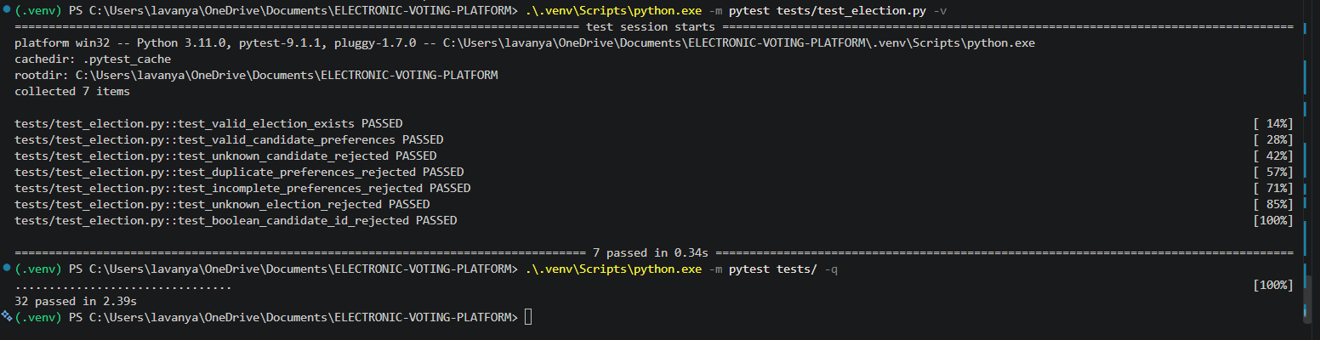
3.7 REST API implementation
We exposed application health and election-information routes, together with credential issuance and ballot-submission endpoints. The development authentication layer additionally provides login and logout routes. Request handling checks expected JSON structure and election/candidate values. In the original backend test configuration, a ballot submission was intentionally refused with HTTP 503 when a live encryption provider was unavailable, avoiding acceptance of an unencrypted ballot.
Method | Endpoint | Purpose
GET | /api/health | Return application health status
GET | /api/elections/current | Provide demonstration election details
POST | /api/auth/login | Establish development authentication session
POST | /api/auth/logout | Clear development session
POST | /api/credentials/issue | Issue one credential after eligibility/authentication checks in the documented backend
POST | /api/ballots | Validate and submit ballot through the voting service
Figure 10: Health API returned HTTP 200 and success JSON
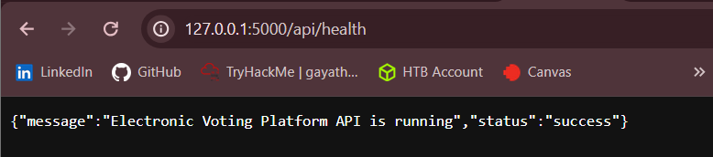
Figure 11: Ballot request refused when encryption was unavailable
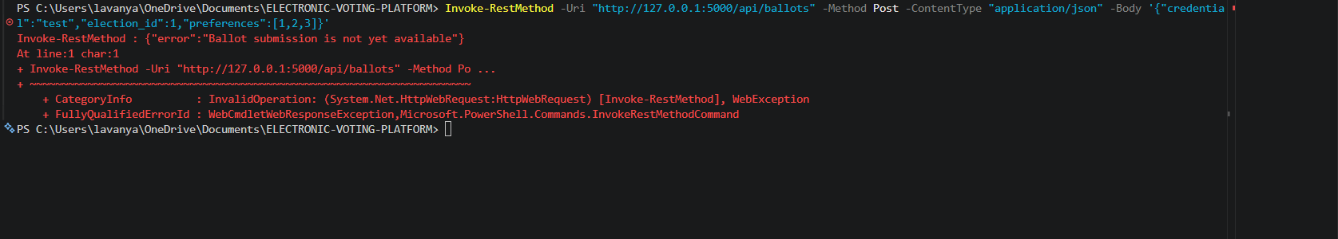
Figure 12: Flask server log showing health and fail-closed ballot responses
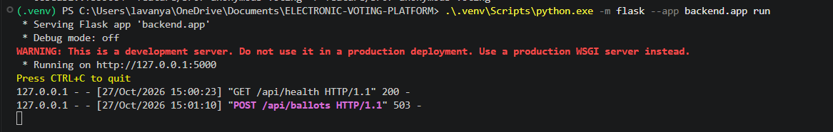
Figure 13: REST request validation tests passed
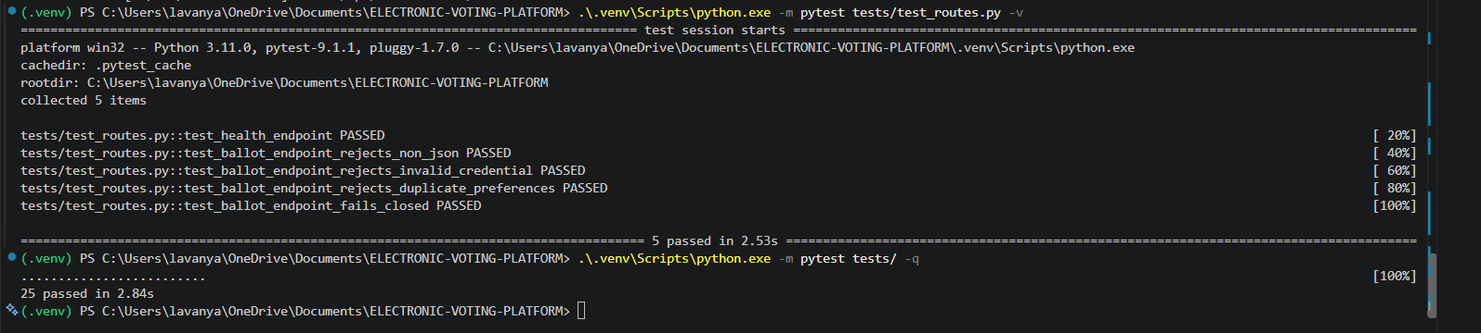
Figure 14: Ballot API tests and 47-test regression stage passed
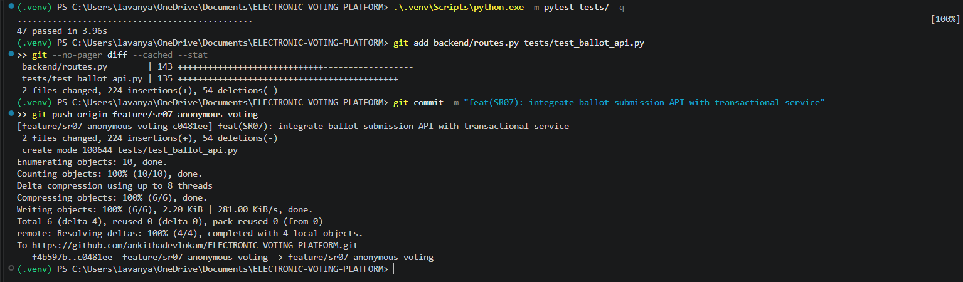
3.8 Development authentication and session safeguards
We added a development-only authentication route to establish a trusted voter identity for issuing credentials in the documented backend. The route verifies a configured Argon2 password hash, checks the voter reference and eligibility, and creates a Flask session with a random CSRF token. Credential issuance uses the session identity and the X-CSRF-Token request header. Logout clears the session after CSRF validation.
The application configuration sets HttpOnly and SameSite cookie attributes, supports the Secure attribute under HTTPS configuration, and specifies a session lifetime. This is a development workflow rather than government-grade voter identity verification, and the configuration by itself does not establish fully enforced inactivity expiry.
Figure 15: Development authentication and full 53-test backend regression run
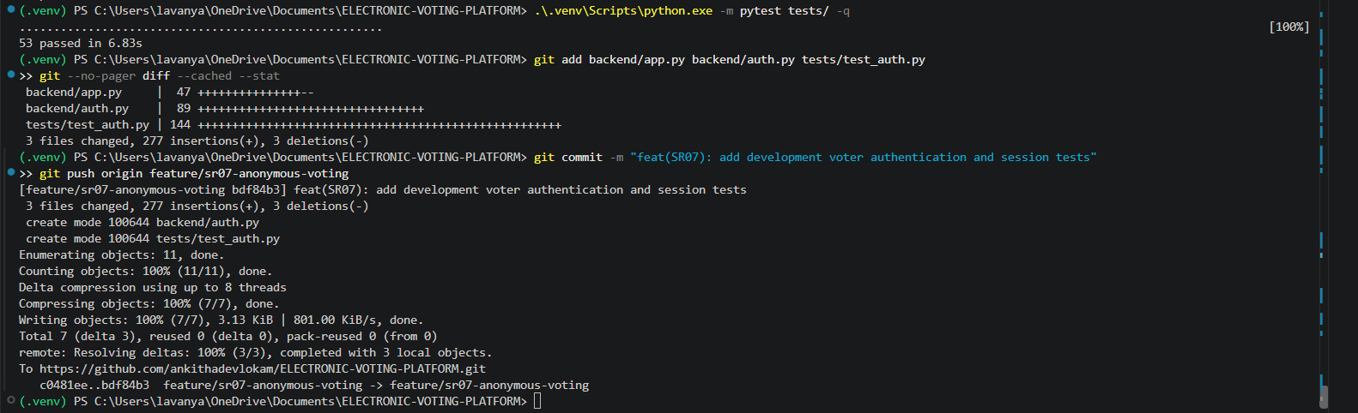
3.9 Test coverage and recorded outcomes
We developed tests incrementally across schema integrity, credential generation, eligibility-controlled issuance, one-use consumption, ballot transaction rollback, election validation, request validation and development authentication. The documented backend regression run completed with 53 tests passing in 6.83 seconds. This result applies to the tested backend revision; it is not represented as a separate test result for every later integrated application revision.
Area tested | Observed result
Database structure | Three tables; ballots table without direct voter identity reference
Credential generation | Secure token generation, SHA-256 hashing and invalid-input tests passed
Issuance | Eligibility, repeat request rejection and rollback tests passed
Consumption | One-use checks, invalid token rejection and rollback tests passed
Ballot service | Validation, test encryption interface and transaction-failure tests passed
REST APIs | Health, election, issuance and ballot request tests passed
Authentication | Development login, CSRF/session and logout tests passed
Backend regression suite | 53 tests passed
3.10 GitHub version control and implementation history
We tracked the selected requirements in GitHub and maintained an incremental commit history for the SR07 backend. The recorded Git history includes database schema changes, credential issuance, consumption, ballot-service integration, election validation, session-protected issuance and authentication tests. We ran tests during implementation before pushing significant changes.
Commit | Development milestone
b398c60 | Database models and structure tests
02c9905 | Credential generation and hashing tests
d38833 | Credential issuance and rollback
683eab1 | One-use consumption and rollback
5f568a4 | Ballot service and transaction tests
988dc10 | API validation and security tests
e1feadf | Election validation and election API
9bc217e | Session-protected issuance
c0481ee | Ballot API integration
f4b597b | Election validation in the ballot service
bdf84b3 | Development authentication and session tests
Figure 16: GitHub push following credential issuance implementation
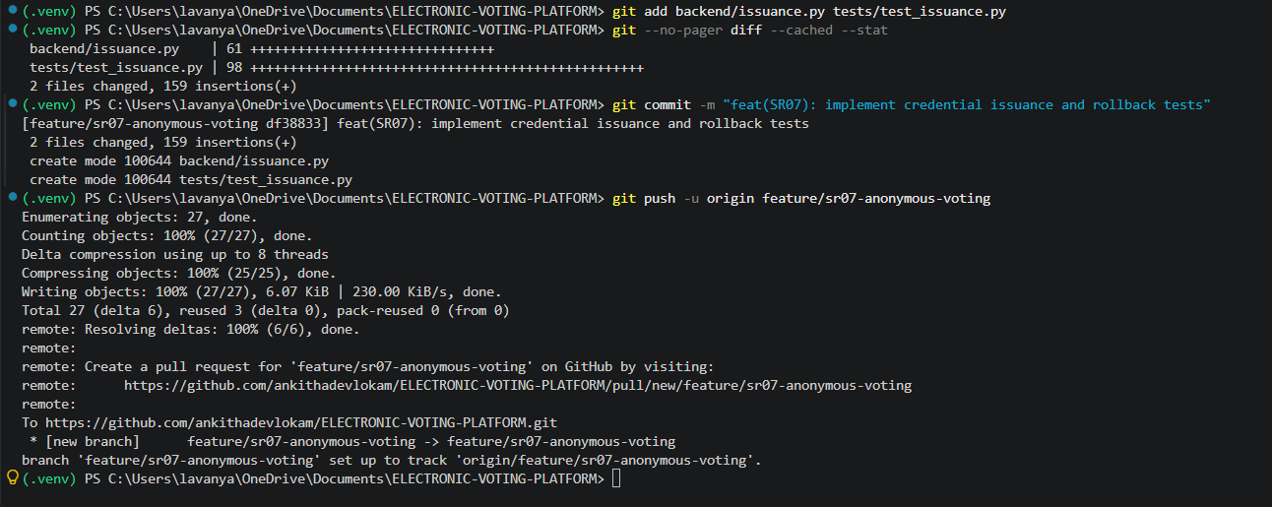
Figure 17: GitHub push following election validation implementation
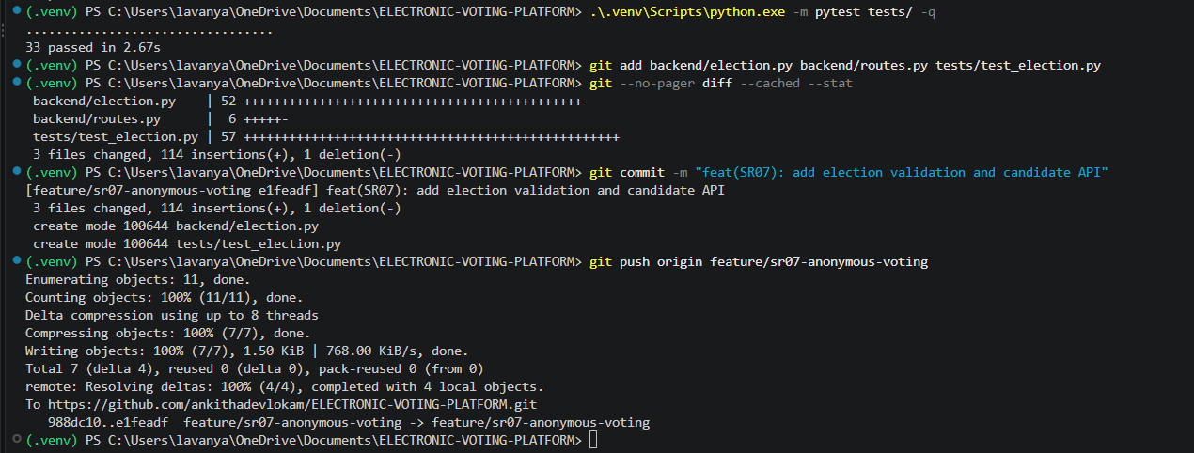
Figure 18: GitHub push following session-protected issuance tests
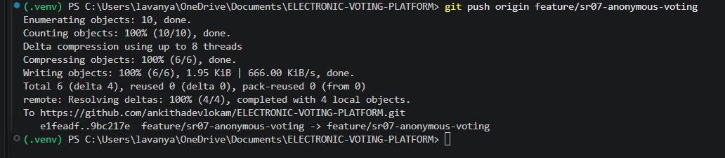
3.11 Browser voting workflow
The browser demonstration follows three stages. First, the application accepts a registered demonstration voter reference and reports that a credential has been issued. The credential is masked by default, with options to reveal or copy it. Second, the interface displays Candidates A, B and C and allows one candidate to be selected. Third, the review screen displays the chosen candidate and requests explicit confirmation before the ballot is submitted.
In the recorded interface sequence, Candidate B is selected. The confirmation dialog explains that the credential will be consumed. The submission success screen reports acceptance by the API, a consumed credential and encrypted storage. A second request using the same voter reference produces the message Credential already issued. This last screen verifies repeat-issuance rejection at the interface level, not a separate live attempt to reuse an already-consumed ballot token.
Figure 19: Credential issued and masked in the voting interface
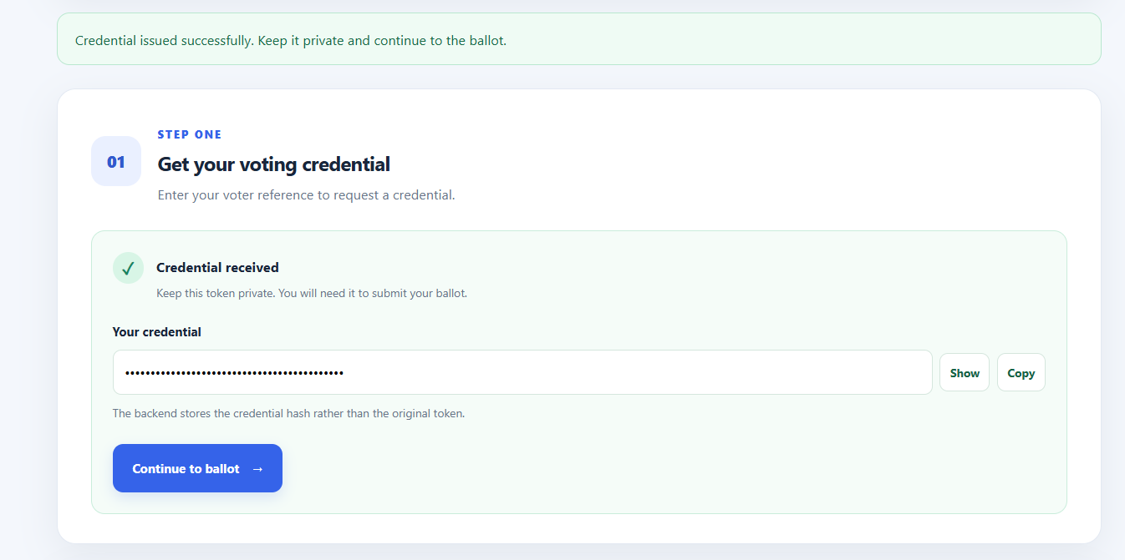
Figure 20: Issued demonstration credential visible through Show control
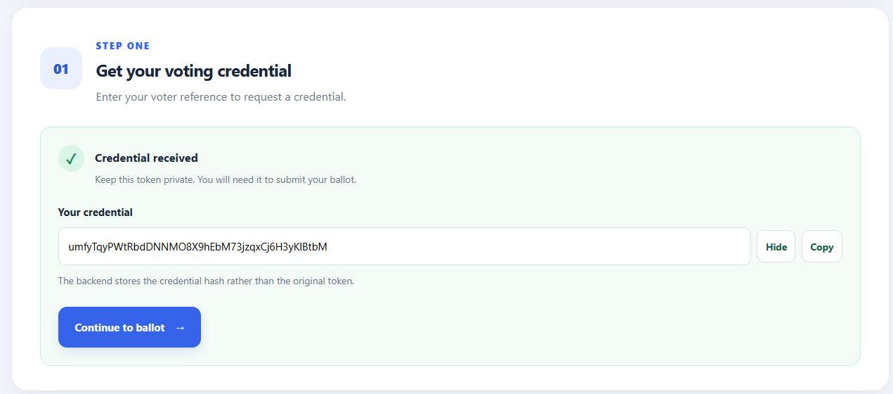
Figure 21: Candidate B selected in the three-candidate interface
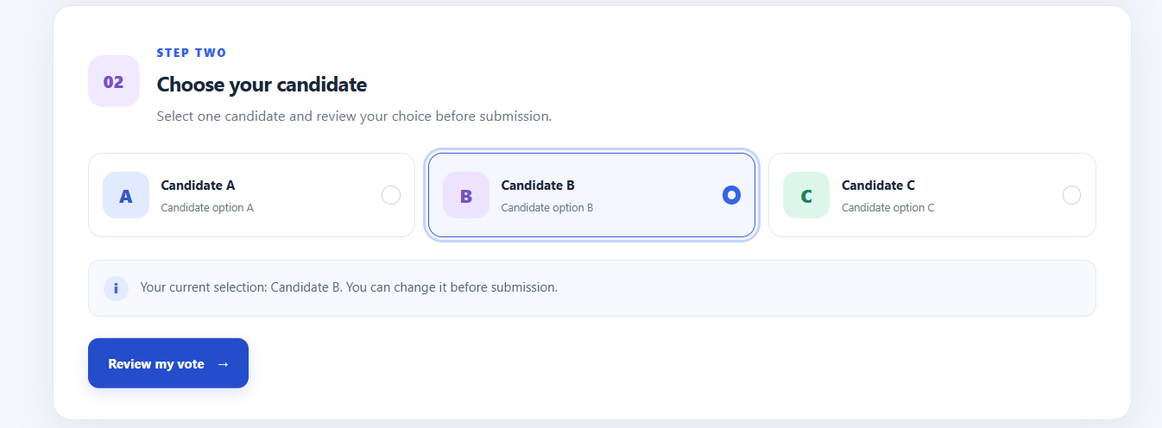
Figure 22: Ballot review showing the selected Candidate B
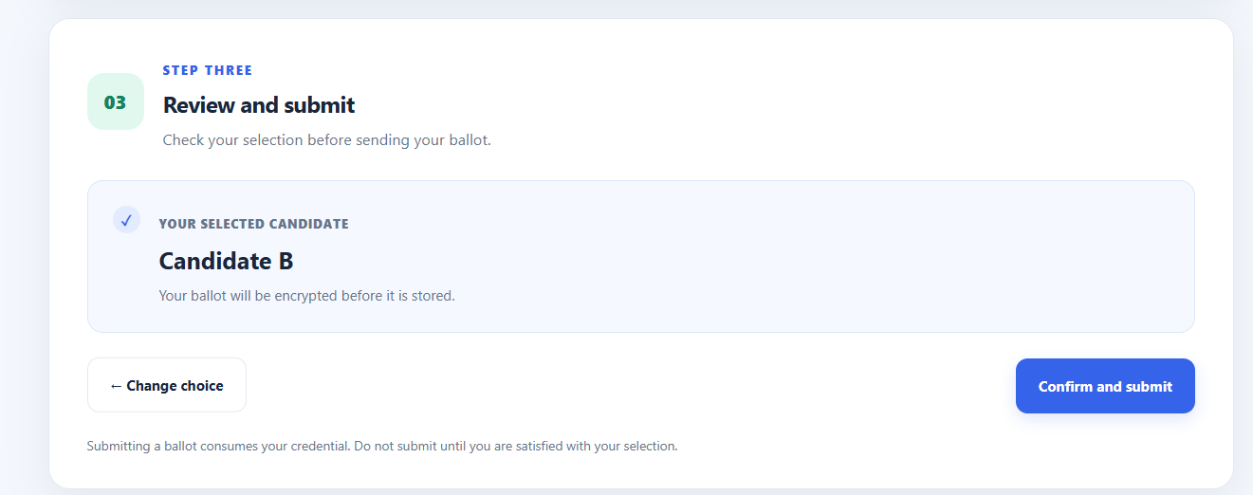
Figure 23: Confirmation warns that submitting consumes the credential
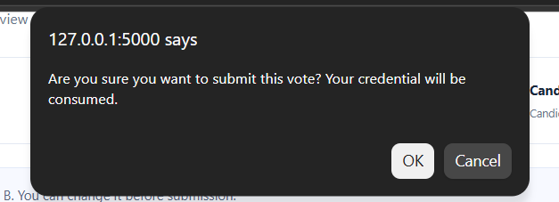
Figure 24: Ballot accepted: API acceptance, credential consumed and encrypted storage reported
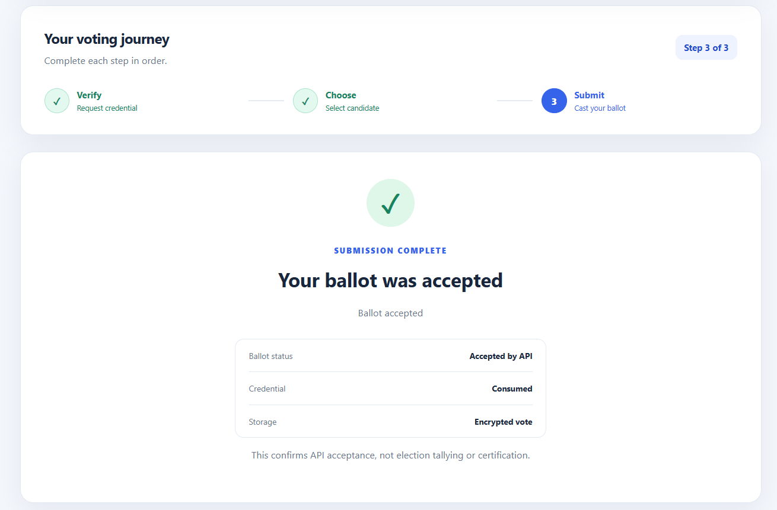
Figure 25: Duplicate credential request rejected for voter-demo-001
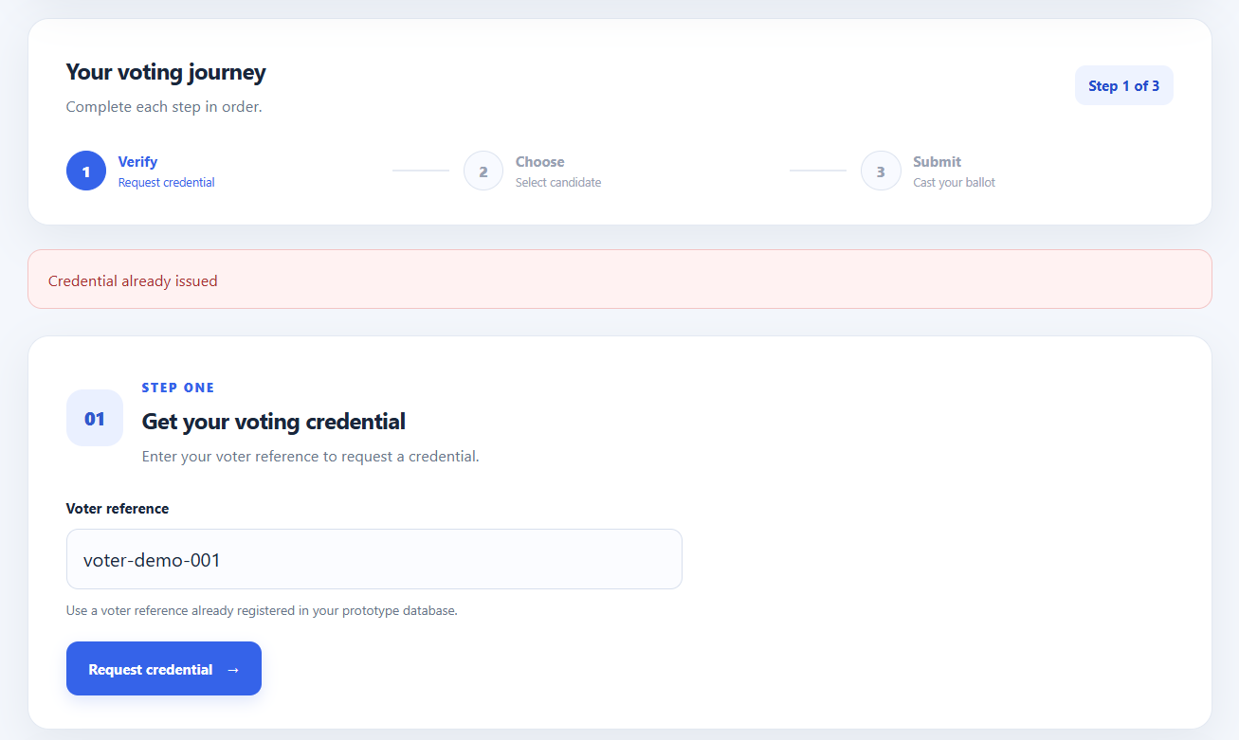
3.12 Stored ballot representation
We inspected the stored voting-data representation and observed binary and hexadecimal characters rather than a readable candidate label. This observation is consistent with stored binary or encoded content. Taken on its own, that screenshot does not identify the exact field or cryptographic algorithm. We therefore interpret it alongside the browser success status and the documented encryption interface, without treating unreadable bytes as independent proof of a particular encryption mode.
Figure 26: Stored ballot-related binary and hexadecimal representation
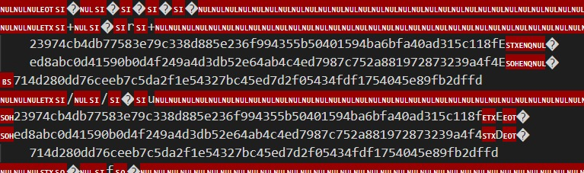
3.13 Security evaluation and scope
The implementation combines direct voter/ballot schema separation, hashed one-use credentials, transactional updates, API validation and development authentication. These controls address important aspects of SR07 and its supporting requirements. The screenshots and tests demonstrate specific behaviours, including successful issuance, accepted ballot submission, repeat-issuance rejection and backend rollback and duplicate-consumption checks.
The prototype does not establish cryptographic unlinkability against timing, server logs or all operational metadata. The local development identity flow is not a production electoral identity service. The browser interface demonstrates single-candidate selection rather than comprehensive federal preferential voting. Our recorded backend test results also do not substitute for large-scale load, deployment, concurrency or independently audited end-to-end security testing. The wider requirements list therefore represents our full security design analysis, while this implementation report focuses on controls supported by the available evidence.
Conclusion
We began with 20 security requirements, compared implementation alternatives and selected ballot secrecy and voter anonymity as our primary design objective. We implemented a modular SR07-oriented backend with credential hashing, eligibility-based issuance, one-use consumption, database transactions, validation, REST services and development authentication. The backend test evidence records 53 passing tests. Our user-interface evidence shows a complete demonstration journey from credential request and candidate selection to ballot acceptance and rejection of another issuance request.
These results demonstrate a functional security-focused voting prototype within the scope described above. The main security finding is that privacy, integrity and access restrictions depend on how credential issuance, transaction processing, ballot storage and the browser workflow operate together; no single field separation or encryption mechanism is sufficient on its own.

